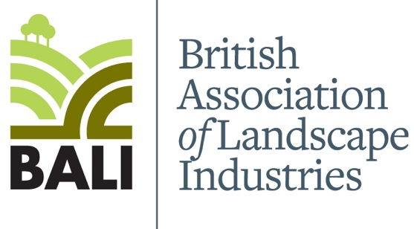

LISS/CSCS Smartcards have been redesigned
Land-based Industry Skills Scheme (LISS) and Construction Skills Certification Scheme (CSCS) is a jointly managed scheme (LISS/CSCS). Over recent years the appearance of the LISS/CSCS SmartCard design have been altered.
More recently if you see a LISS/CSCS SmartCard that looks slightly different to what you expect, do not assume that it is invalid or fake. Instead, use one of the following tools to check if the SmartCard is currently valid:
- The Go Smart app is a free application for reading both LISS/CSCS and CSCS SmartCards, which can easily be downloaded to iOS devices, Android devices and PCs/Laptops. All LISS/CSCS cards are Smart which contain a chip that allows the card to be scanned electronically. Employers can read the information stored on the SmartCard using a smartphone or tablet device with the free Go Smart app installed.

- The Go Smart online card checker – Do not change the scheme, you will find your LISS/CSCS SmartCard under the Construction Skills Certification Scheme.
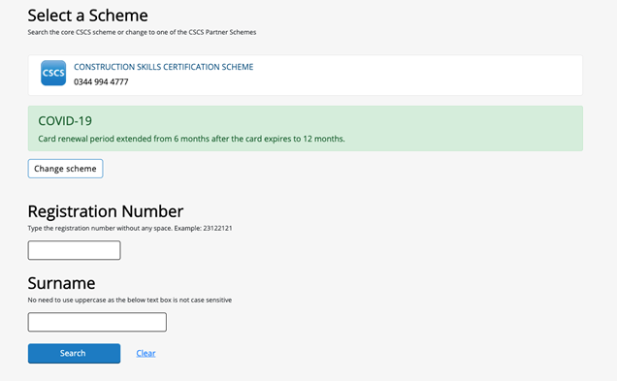

- The CITB card checker (for cards issued before 9th December 2019 only).

- Access your CSCS Online account: If you already have an account, please login to view the status of your card.

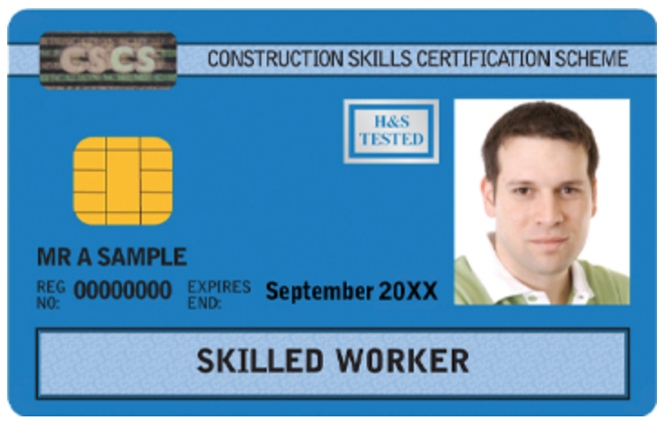
There are currently three card designs in circulation

LISS/CSCS cards issued before 9th December 2019
All cards issued before 9th December 2019 look like the image below.

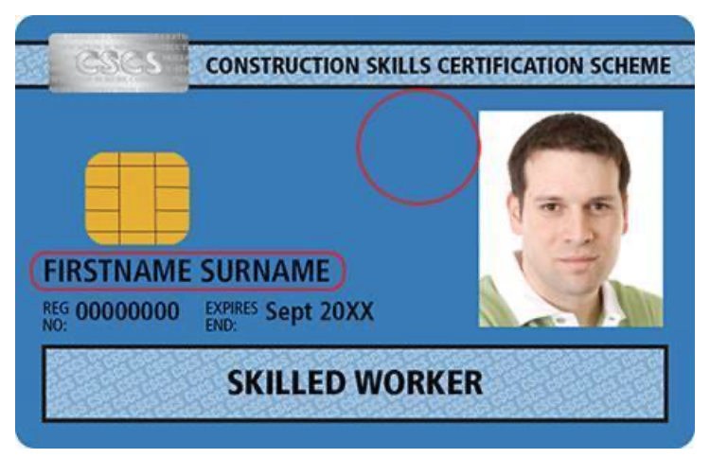
CSCS cards issued between 9th December 2019 and end of May 2020
These cards have 2 key differences.
1. The cardholder’s full name appears on the card, instead of just their initials and last name.
2. The HS&E tested holofoil no longer appears on the card.
These changes are highlighted on the image below.

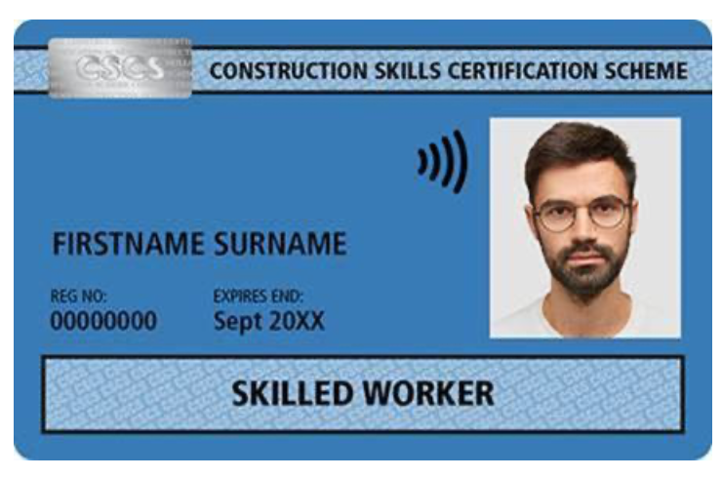
Cards issued since June 2020
A new card design was launched 01 June 2020.
The new design has the following design differences:
1. The smart chip embedded in the card is no longer visible
2. There is a contactless symbol next to the cardholder’s photograph

If you have any further questions about the changes to the appearance of the LISS/CSCS SmartCards, please fill in our enquiry page online and a member of the LISS/CSCS team will be in contact within 48 hours.

